PROMISE & PRACTICE · DEEP DIVE · SOURCE ANALYSIS
The Election of 1860 — House & Divided
How the Numbers Elected Lincoln
Name: ______________________________ Period: _____ Date: ________________
WHAT I CAN DO TODAY I can read primary sources about The Election of 1860 — House & Divided, weigh who made each one and why, and use evidence to answer historical questions.
Directions. Numbers are a primary source too. Read the 1860 returns and the campaign cartoons, then explain how the math worked

THE SOURCES
SOURCE A · THE DATA · 1860 — The returns
#activity .rtab{width:100%;border-collapse:collapse;margin:8px 0 2px;font-size:14.5px}
#activity .rtab th,#activity .rtab td{border:1px solid var(--hair);padding:9px 12px;text-align:left;color:var(--body)}
#activity .rtab th{color:var(--accent);text-transform:uppercase;letter-spacing:.06em;font-size:11.5px}
#activity .rtab td.n{text-align:right;font-variant-numeric:tabular-nums;color:var(--ink)}
#activity .rtab tr.win td{background:rgba(224,128,95,.1)}
CANDIDATE PARTY REGION OF SUPPORT POPULAR VOTE % ELECTORAL
Abraham Lincoln Republican North / West 1,866,000 40% 180
Stephen Douglas Northern Democrat scattered, North 1,380,000 29% 12
John C. Breckinridge Southern Democrat Deep South 848,000 18% 72
John Bell Constitutional Union Border South 591,000 13% 39.
Election of 1860 returns (rounded). 152 electoral votes were needed to win. Public-domain data.
SOURCE B · THE CARTOON — “The National Game”
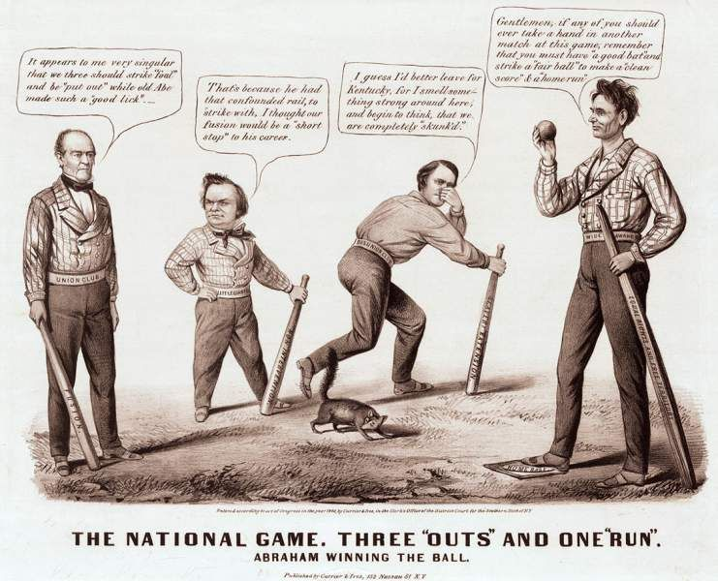
“The National Game. Three ‘Outs’ and One ‘Run’” — Currier & Ives, 1860, public domain (Library of Congress).

YOUR WORK
QUESTION 1 STEP 1 · READ THE TABLE
Lincoln won only about 40% of the popular vote — less than the other three combined. So how did he win the election? (Look at the electoral-vote column.)
____________________________________________________________________________________________
____________________________________________________________________________________________
____________________________________________________________________________________________
QUESTION 2 STEP 1 · READ THE TABLE
Douglas came 2nd in the popular vote (29%) but won only 12 electoral votes — far fewer than Breckinridge's 72 on just 18%. What does that tell you about where each man's votes were?
____________________________________________________________________________________________
____________________________________________________________________________________________
____________________________________________________________________________________________
QUESTION 3 STEP 2 · A SECTIONAL MAP
Lincoln carried the free North; Breckinridge swept the Deep South; Lincoln wasn't even on most Southern ballots. What does this pattern reveal?
☐ A. that most Americans agreed on the issues
☐ B. that the nation was already dividing into two separate political regions
☐ C. that the election was fraudulent
☐ D. that slavery was no longer an issue
QUESTION 4 STEP 3 · WHY IT MATTERED
Lincoln promised only to stop slavery from spreading, not to end it in the South. So why did his election — a fair, legal election — convince the South to leave the Union? Answer in two or three sentences.
____________________________________________________________________________________________
____________________________________________________________________________________________
____________________________________________________________________________________________
____________________________________________________________________________________________
Promise & Practice · ShadowDog Digital Studios · Unit 2

TEACHER ANSWER KEY — The Election of 1860 — House & Divided

QUESTION 1: Open response.
Look for a response along the lines of: “Lincoln won because, even with 40%, his electoral votes…”
QUESTION 2: Open response.
Look for a response along the lines of: “Douglas's votes were spread thin across many states, while Breckinridge's were…”
QUESTION 3: Correct — B. that the nation was already dividing into two separate political regions
Exactly. The vote didn't split by candidate so much as by region. The country was no longer arguing as one nation — it was already voting as two.
QUESTION 4: Open response.
Look for a response along the lines of: “The South left because the election proved…”

